[Test Plan] Website https://belajar-bareng.onrender.com

Document Status | [DRAFT]
Test Plan Creator | Dear Frans Lyandre Simanjorang
Test Plan Reviewer | - M Ridhwan K  - Reviewer_2  - Reviewer_3

Introduction

Overview Feature to be tested
This Test Plan is used as a learning tool in the Testing & Bug Management process, aiming to help learners understand the needs and importance of creating a comprehensive Test Plan. It describes the objectives, scope, schedule, risks, and approach used to ensure that the system functions according to user requirements. This document includes the main components required during the testing phase, such as Test Items, In-Scope and Out-of-Scope Testing, Testing Approach, Test Environment, and Test Deliverables.

This Test Plan is made to ensure that the Login and Add User features on the website https://belajar-bareng.onrender.com/ function properly and meet the acceptance criteria. Testing will focus on functional behavior, input validation, and form handling to prevent user errors and ensure reliable system behavior.

Goals and Objective
The goal of this testing activity is to ensure that the Login and Add User features meet functional requirements and operate as expected under both valid and invalid scenarios.
The objectives include:
- Verifying the Login process using valid, invalid, and empty inputs.
- Validating Add User behavior including numeric-only age, unique username rules, and mandatory fields.
- Identifying defects and documenting them as part of the learning process.
This Test Plan also serves as foundational training for preparing test documentation, understanding testing flow, and applying good QA practices.
Phase 1 of the project includes delivering and validating the following core functionalities:
- Login Feature
- Ensuring users can log in using valid credentials.
- Ensuring mandatory field validation works.
- Ensuring appropriate error messages appear when incorrect password or empty fields are submitted.
- Add User Feature
- Ensuring new users can be added using unique usernames.
- Ensuring Age input accepts only numeric values and rejects negative numbers.
- Ensuring mandatory field validation is executed properly.
- Ensuring the system prevents duplicate usernames.

Must-have functionality is prioritized over delivery timeline. The testing will confirm that all critical behaviors follow the defined requirements.

Test Item
List of test items (feature / product)

No | Feature | Test Item
#1 | Login | - Login with valid credentials  - Login with invalid credentials  - Login with user doesn’t exist  - Login with empty fields
#2 | Add User | - Add user with valid input  - Add user with invalid input  - Add user with numeric username  - Add user with non-numeric age  - Add user with negative age  - Add user with 0 age  - Add user with duplicate username

In Scope Testing
List of in feature to be tested

No | Feature | Requirement / Design specifications
#1 | Login | 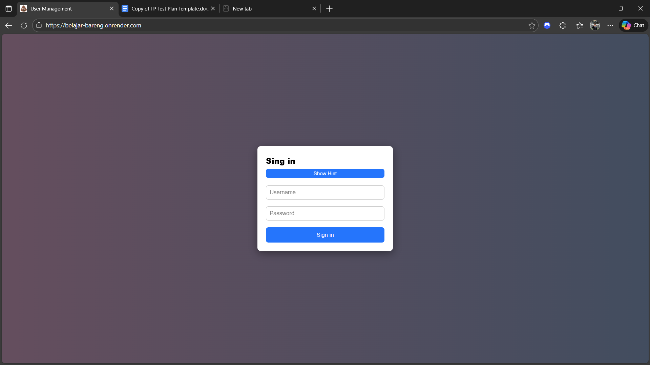
#2 | Add Users | 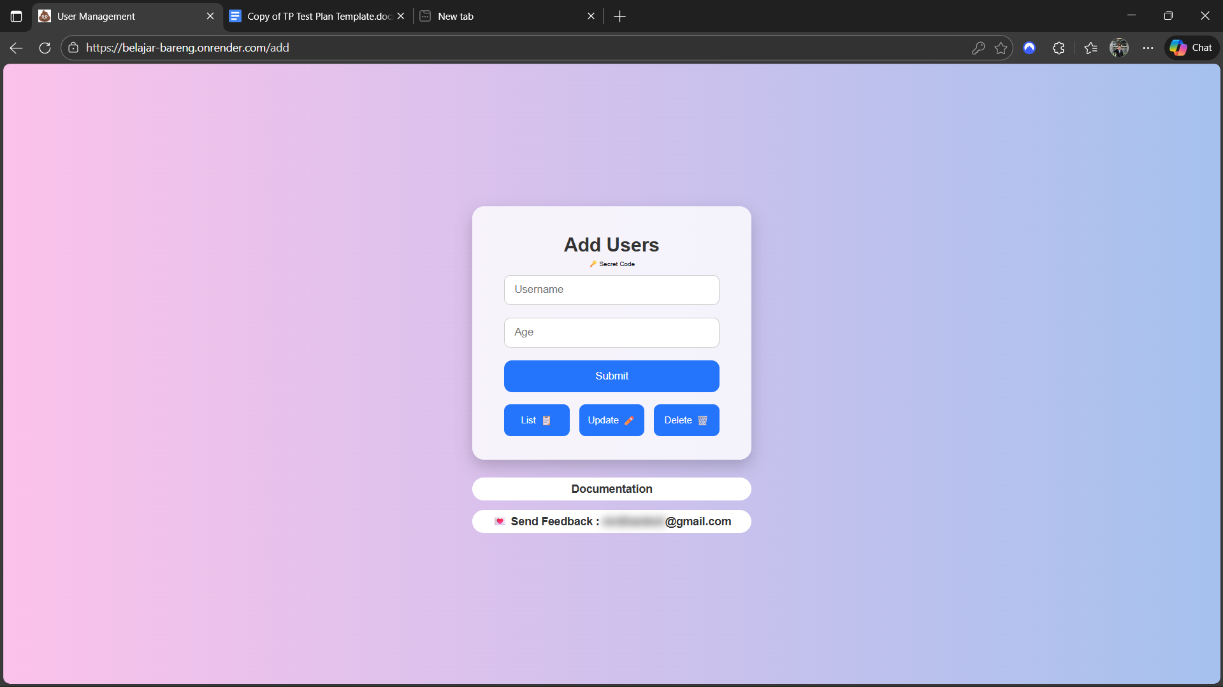

Out of Scope Testing
List the features of the software / product which will not be tested.
No | Feature | Reasons
#1 | Register / Sign Up | Not included in testing phase
#2 | Logout | This testing phase will be focus to test login feature
#3 | List Users | This testing phase will be focus to test add Users
#4 | Update User | Not included in testing phase
#5 | Delete User | Not included in testing phase
# 6 | Performance Test | Outside manual function coverage

Testing Approach
Testing will be performed using Manual Functional Testing with support from Exploratory Testing.
Positive and negative scenarios will be covered based on the defined requirements.
All defects discovered during test execution will be recorded in a Defect Report, including steps to reproduce, expected results, and screenshots when applicable.

Test Environment
Information about testing environment that will be used during testing phase e.g URL, and version of App
- Website: http://belajar-bareng.onrender.com/
- Environment: Production
- Browser: Chrome, Edge
- Device: Desktop (Windows 11)

Test Deliverables
- Test Plan (this document): [link]
- Test Case: [link]
- Defect Report: [link]
- Test Report: [link]

Testing Timeline
No | Task | Estimation Time |  | Actual Time
No | Task | Start Date | Finish Date | Start Date | Finish Date
#1 | Develop Test Planning | 2 Dec 2025 | 3 Dec 2025
#2 | Develop Test Case | 3 Dec 2025 | 4 Dec 2025
#3 | Test Case Review | 4 Dec 2025 | 4 Dec 2025
#4 | Execute Test | 5 Dec 2025 | 9 Dec 2025 | 5 Dec 2025 | 6 Dec 2025

